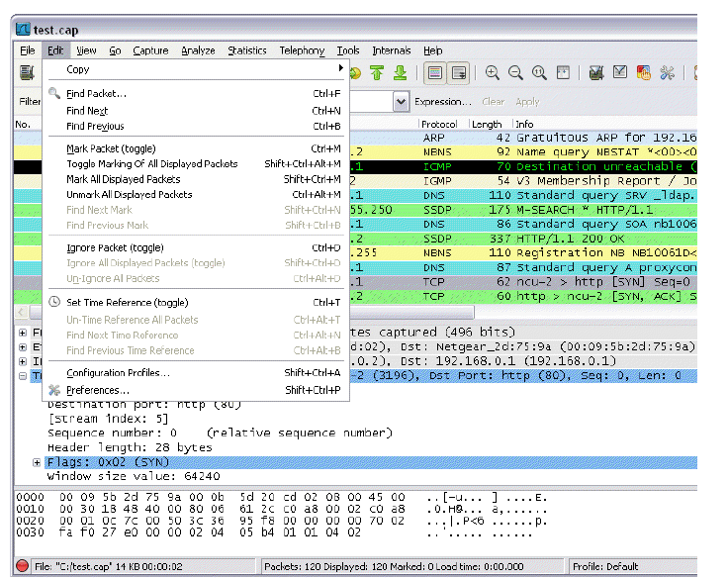
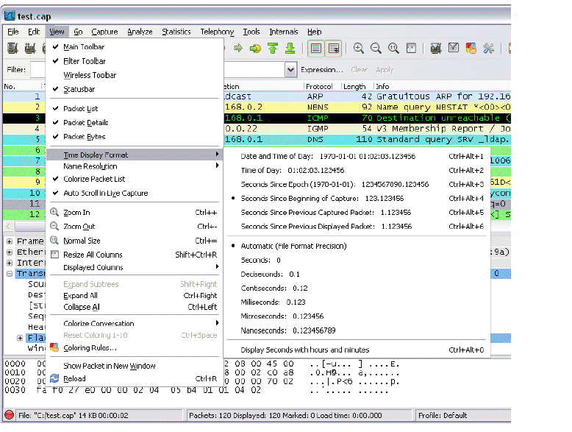
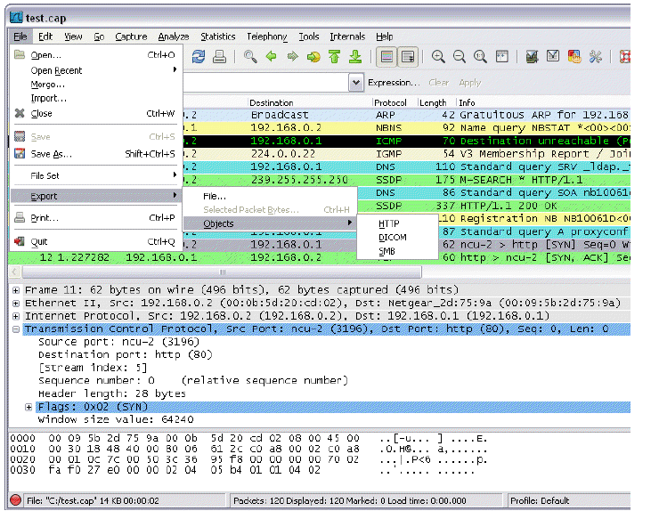
The "File" menu

This menu contains items to open and merge capture files, save / print / export capture files in whole or in part, and to quit from Wireshark.
File menu items:

Menu Item: Open
Accelerator: Ctrl+O
Description: This menu item brings up the file open dialog box that allows you to load a capture file for viewing.

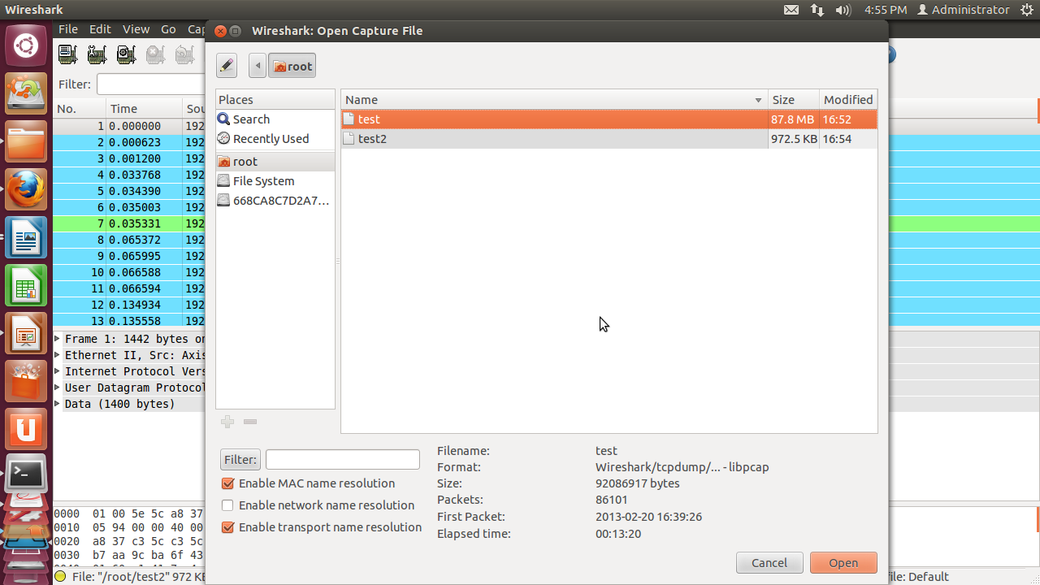
Menu Item: Open Recent.
Description: This menu item shows a submenu containing the recently opened capture files.
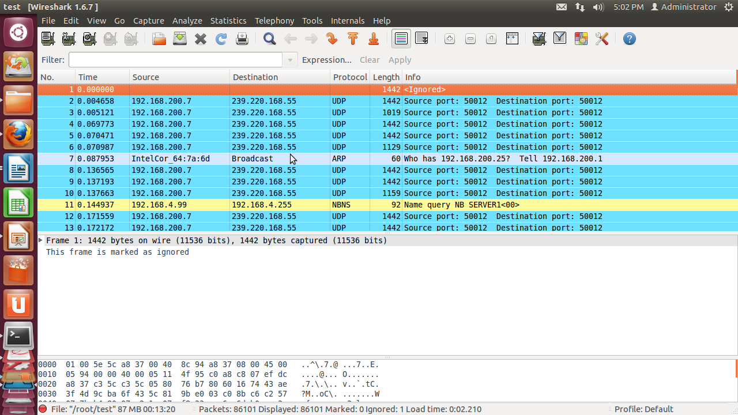
Clicking on one of the submenu items will open the corresponding capture file directly.
Menu Item: Merge.
Description: This menu item brings up the merge file dialog box that allows you to merge a
capture file into the currently loaded one.
Menu Item: Import.
Description: This menu item brings up the import file dialog box that allows you to import a
text file into a new temporary capture.
Menu Item: Close
Accelerator: Ctrl+W
Description: This menu item closes the current capture.
Menu Item: Save
Accelerator: Ctrl+S
Description: This menu item saves the current capture.
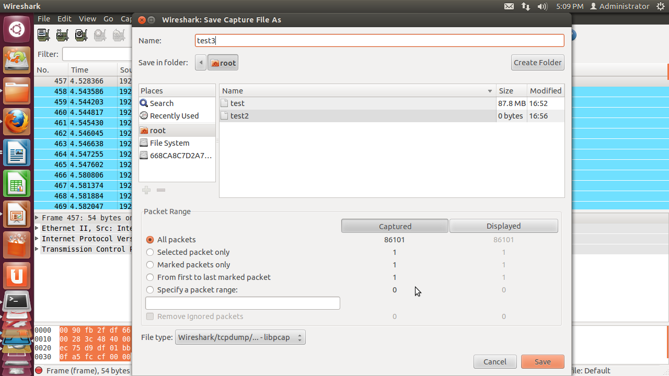

Menu Item: Save As
Accelerator: Shift+Ctrl+S
Description: This menu item allows you to save the current capture file to whatever file you
would like.
Menu Item: File Set > List Files.
Description: This menu item allows you to show a list of files in a file set.
Menu Item: File Set > Next File
Description: If the currently loaded file is part of a file set, jump to the next file in the set. If it
isn't part of a file set or just the last file in that set, this item is greyed out.
Menu Item: File Set > Previous File
Description: If the currently loaded file is part of a file set, jump to the previous file in the set.
If it isn't part of a file set or just the first file in that set, this item is greyed out.

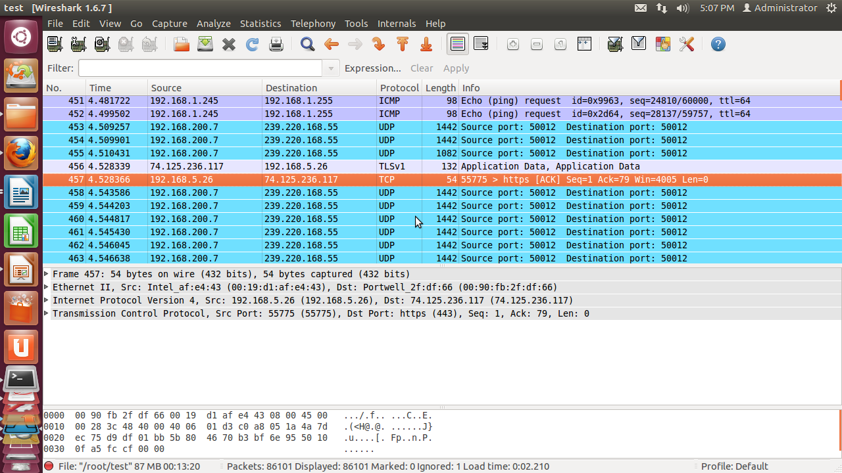

Menu Item: Export > File
Description: This menu item allows you to export all (or some) of the packets in the capture
file to file.
Menu Item: Export > Selected Packet Ctrl+H Bytes.
Description: This menu item allows you to export the currently selected bytes in the packet
bytes pane to a binary file.
Menu Item: Export > Objects > HTTP
Description: This menu
item allows you to export all or some of the captured HTTP objects
into local files.
Menu Item: Export > Objects > DICOM
Description: This menu item allows you to export all or some of the captured DICOM objects
into local files.
Menu Item: Export > Objects >SMD
Description: This menu item allows you to export all or some of the captured SMB objects into
local files.
Menu Item: Print.
Accelerator: Ctrl+P
Description: This menu item allows you to print all (or some) of the packets in the capture file.
Menu Item: Quit.
Accelerator: Ctrl+Q
Description: This menu item allows you to quit from Wireshark.

The "Edit" menu
This menu contains items to find a packet, time reference or mark one or more packets, handle
configuration profiles, and set your preferences.

Edit menu items
Menu Item: Copy > Description
Accelerator: Shift+Ctrl+D
Description: This menu item will copy the description of the selected item in the detail view to the clipboard.

Menu Item: Copy > > Fieldname
Accelerator: Shift+Ctrl+F
Description: This menu item will copy the fieldname of the selected item in the detail view to the clipboard.
Menu Item: Copy > Value
Accelerator: Shift+Ctrl+V
Description: This menu item will copy the value of the selected item in the detail view to the clipboard.
Menu Item: Copy > As Filter
Accelerator: Shift+Ctrl+C
Description: This menu item will use the selected item in the detail view to create a display filter. This display filter is then copied to the clipboard.
Menu Item: Find Packet.
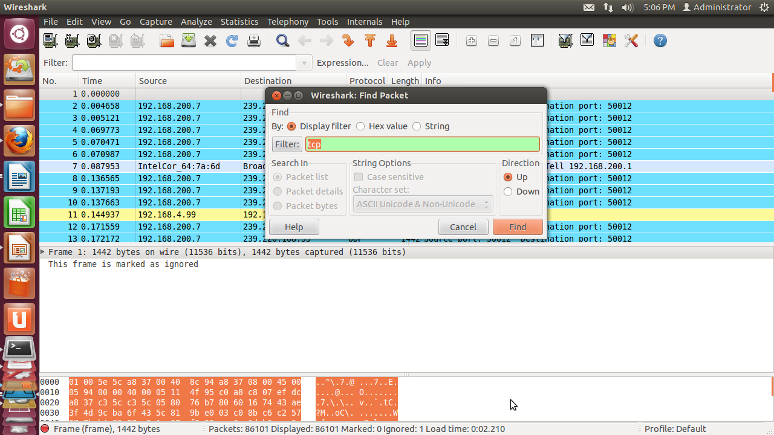
Accelerator: Ctrl+F
Description: This menu item brings up a dialog box that allows you to find a packet by many criteria.
Menu Item: Find Next
Accelerator: Ctrl+N
Description: This menu item tries to find the next packet matching the settings from "Find Packet...".

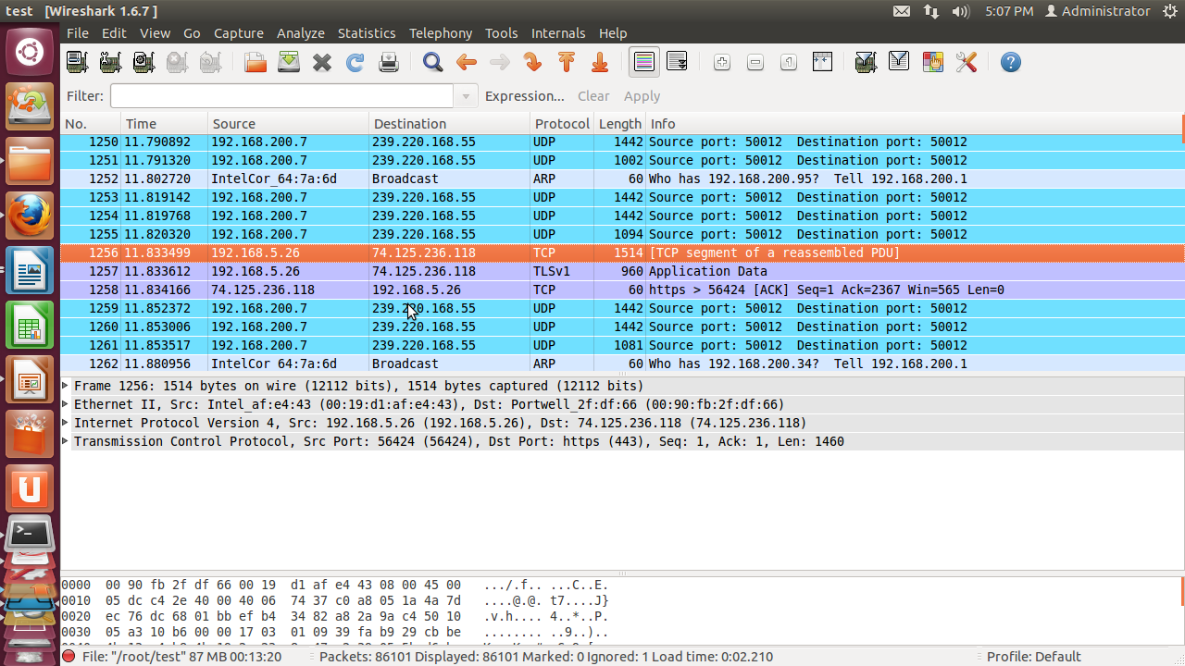

Menu Item: Find Previous
Accelerator: Ctrl+B
Description: This menu item tries to find the previous packet matching the settings from "Find Packet...".

Menu Item: Mark Packet (toggle)
Accelerator: Ctrl+M
Description: This menu item "marks" the currently selected packet.

Menu Item: Toggle Marking Of All Displayed Packets
Accelerator: Shift+Ctrl+Alt+M
Description: This menu item toggles the mark on all displayed packets.
Menu Item: Mark All Displayed Packets
Accelerator: Shift+Ctrl+M
Description: This menu item "marks" all displayed packets.
Menu Item: Unmark All Displayed Packets
Accelerator:Ctrl+Alt+M
Description: This menu item "Unmarks" all displayed packets.
Menu Item: Find Next Mark
Accelerator: Shift+Ctrl+N
Description: Find the next marked packet.
Menu Item: Find Previous Mark
Accelerator: Shift+Ctrl+B
Description: Find the previous marked packet.
Menu Item: Ignore Packet (toggle)
Accelerator: Ctrl+D
Description: This menu item marks the currently selected packet as ignored.

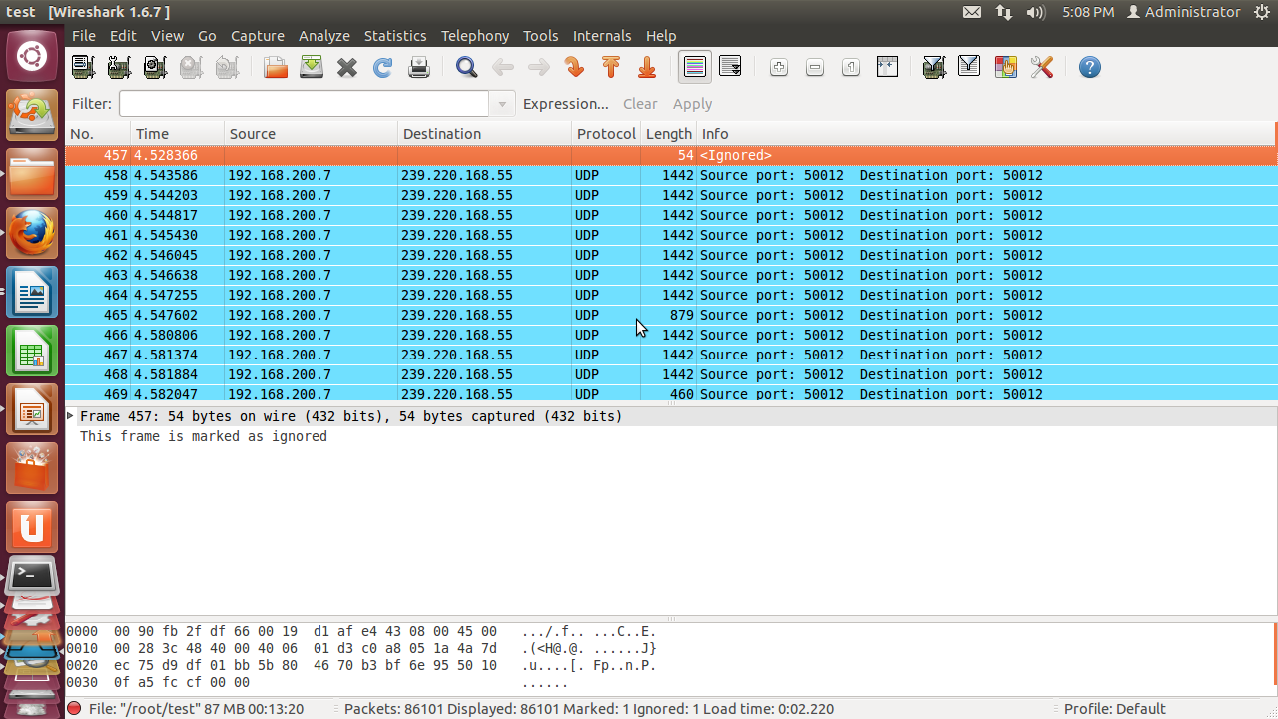

Menu Item: Ignore All Displayed Packets (toggle)
Accelerator: Shift+Ctrl+D
Description: This menu item marks all displayed packets as ignored.

Menu Item: Un-Ignore All Packets
Accelerator:Ctrl+Alt+D
Description: This menu item unmarks all ignored packets.

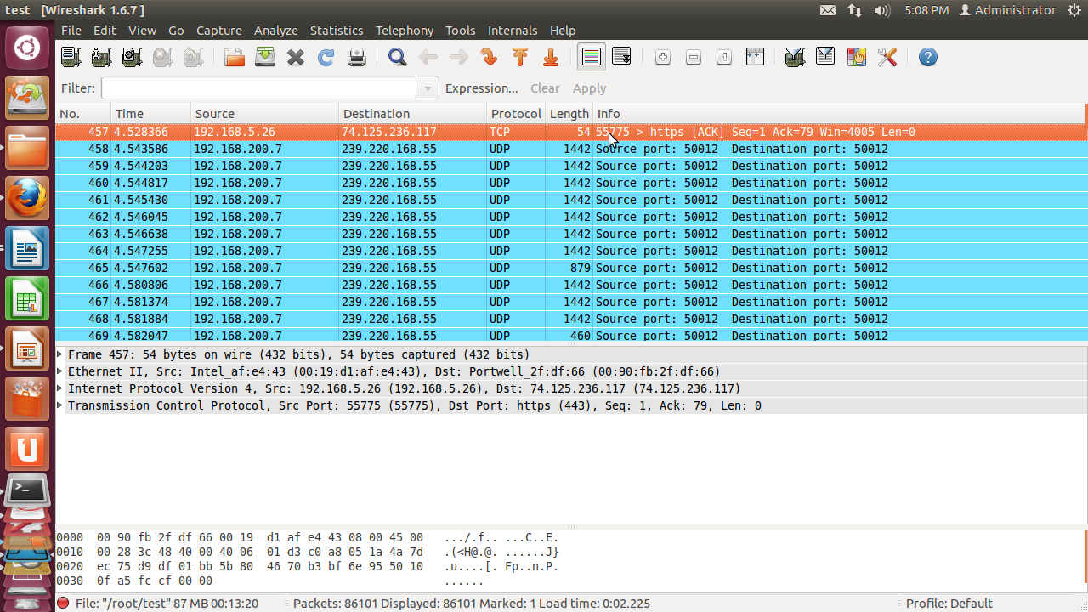
Menu Item: Set Time Reference (toggle)
Accelerator:Ctrl+T
Description: This menu item set a time reference on the currently selected packet.
Menu Item: Un-Time Reference All Packets
Accelerator:Ctrl+Alt+T
Description: This menu item removes all time references on the packets.

Menu Item: Find Next Time Reference
Accelerator: Ctrl+Alt+N
Description: This menu item tries to find the next time referenced packet.
Menu Item: Find Previous Time Reference
Accelerator: Ctrl+Alt+B
Description: This menu item tries to find the previous time referenced packet.
Menu Item: Configuration Profiles.
Accelerator: Shift+Ctrl+A
Description: This menu item brings up a dialog box for handling configuration profiles.
Menu Item: Preferences.
Accelerator: Shift+Ctrl+P
Description: This menu item brings up a dialog box that allows you to set preferences for many parameters that control Wireshark. You can also save your preferences so Wireshark will use them the next time you start it.

The View menu
This menu controls the display of the captured data, including colorization of packets, zooming the font, showing a packet in a separate window, expanding and collapsing trees in packet details.
Menu Item: Main Toolbar
Description: This menu item hides or shows the main toolbar.
Menu Item: Filter Toolbar
Description: This menu item hides or shows the filter toolbar.

Menu Item: Wireless Toolbar(Windows only)
Description: This menu item hides or shows the wireless toolbar.

Menu Item: Statusbar
Description: This menu item hides or shows the statusbar.

Menu Item: Packet List
Description: This menu item hides or shows the packet list pane.

Menu Item: Packet Details
Description: This menu item hides or shows the packet details pane.

Menu Item: Packet Bytes
Description: This menu item hides or shows the packet bytes pane.

Menu Item: Time Display Format > Date and Time of Day: 1970-01-01 01:02:03.123456
Description: Selecting this tells Wireshark to display the time stamps in date and time of day format.

Menu Item: Time Display Format > Time of Day: 01:02:03.123456
Description: Selecting this tells Wireshark to display time stamps in time of day format.
Menu Item: Time Display Format > Seconds Since Epoch (1970- 01-01): 1234567890.123456
Description: Selecting this tells Wireshark to display time stamps in seconds since 1970-01-01 00:00:00.
Menu Item: Time Display Format > Seconds Since Beginning of Capture: 123.123456
Description: Selecting this tells Wireshark to display time stamps in seconds since beginning of capture format.
Menu Item: Time Display Format > Seconds Since Previous Captured Packet: 1.123456
Description: Selecting this tells Wireshark to display time stamps in seconds since previous captured packet format.
Menu Item: Time Display Format > Automatic (File Format Precision)
Description: Selecting this tells Wireshark to display time stamps with the precision given by the capture file format used.

Menu Item: Time Display Format > Seconds: 0
Description: Selecting this tells Wireshark to display time stamps with a precision of one second.
Menu Item: Time Display Format > ...seconds: 0
Description: Selecting this tells Wireshark to display time stamps with a precision of one second, decisecond, centisecond, millisecond, microsecond or nanosecond,
Menu Item: Time Display Format > Display Seconds with hours and minutes
Description: Selecting this tells Wireshark to display time stamps in seconds, with hours and minutes.
Menu Item: Name Resolution > Resolve Name
Description: This item allows you to trigger a name resolve of the current packet only,

Menu Item: Name Resolution > Enable for MAC Layer
Description: This item allows you to control whether or not Wireshark translates MAC addresses into names.

Menu Item: Name Resolution > Enable for Network Layer
Description: This item allows you to control whether or not Wireshark translates network addresses into names.

Menu Item: Name Resolution > Enable for Transport Layer
Description: This item allows you to control whether or not Wireshark translates transport addresses into names.

Menu Item: Colorize Packet List
Description: This item allows you to control whether or not Wireshark should colorize the packet list.
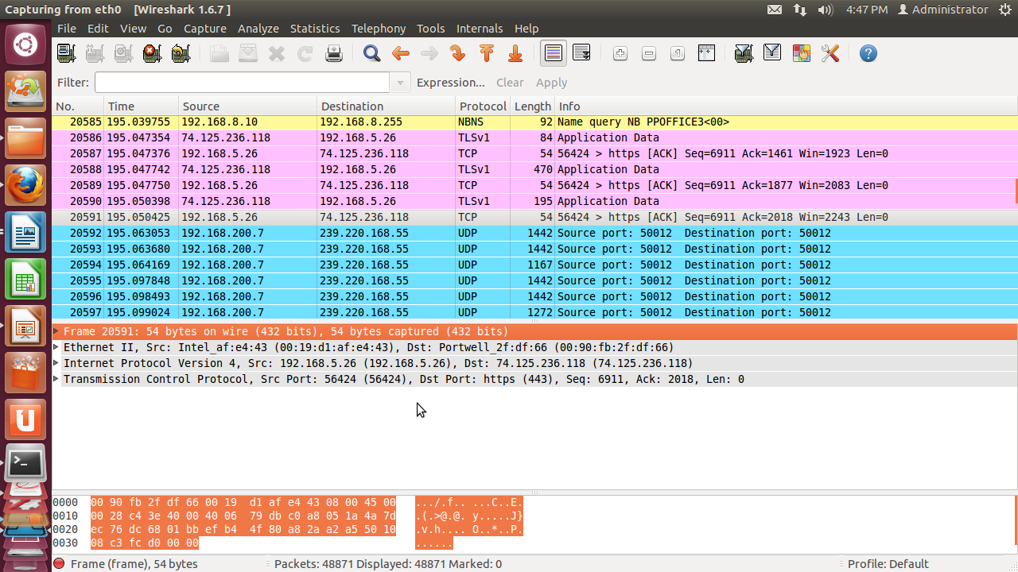
Menu Item: Auto Scroll in Live Capture
Description: This item allows you to specify that Wireshark should scroll the packet list pane as new packets come in, so you are always looking at the last packet. If you do not specify this, Wireshark simply adds new packets onto the end of the list, but does not scroll the packet list pane.

Menu Item: Zoom In
Accelerator: Ctrl++
Description: Zoom into the packet data (increase the font size).
Menu Item: Zoom Out
Accelerator: Ctrl+-
Description: Zoom out of the packet data (decrease the font size).

Menu Item: Normal Size
Accelerator: Ctrl+=
Description: Set zoom level back to 100% (set font size back to normal).

Menu Item: Resize All Columns
Accelerator: Shift+Ctrl+R
Description: Resizing may take a significant amount of time, especially if a large capture file is loaded.

Menu Item: Displayed Columns
Description: This menu items folds out with a list of all configured columns.
These columns can now be shown or hidden in the packet list.

Menu Item: Expand Subtrees
Accelerator: Shift+Right
Description: This menu item expands the currently selected subtree in the packet details tree.

Menu Item: Expand All
Accelerator: Ctrl+Right
Description: Wireshark keeps a list of all the protocol subtrees that are expanded, and uses it to ensure that the correct subtrees are expanded when you display a packet. This menu item expands all subtrees in all packets in the capture.

Menu Item: Collapse All
Accelerator: Ctrl+Left
Description: This menu item collapses the tree view of all packets in the capture list.

Menu Item: Colorize Conversation
Description: This menu item brings up a submenu that allows you to color packets in the packet list pane based on the addresses of the currently selected packet. This makes it easy to distinguish packets belonging to different conversations.

Menu Item: Colorize Conversation >Color 1-10
Description: These menu items enable one of the ten temporary color filters based on the currently selected conversation.

Menu Item: Colorize Conversation > Reset coloring
Description: This menu item clears all temporary coloring rules.

Menu Item: Colorize Conversation > New Coloring Rule.
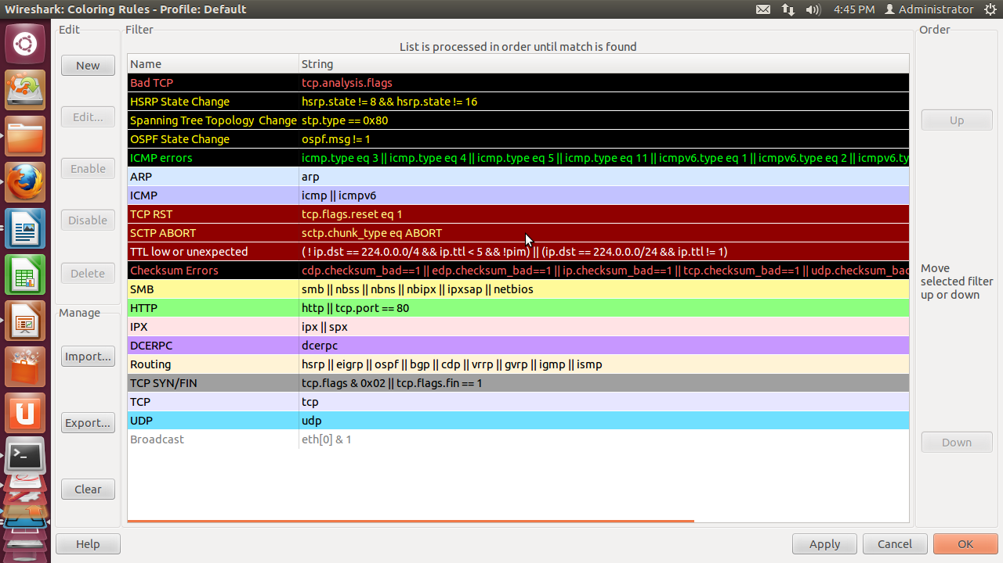
Description: This menu item opens a dialog window in which a new permanent coloring rule can be created based on the currently selected conversation.

Menu Item: Coloring Rules.
Description: This menu item brings up a dialog box that allows you to color packets in the packet list pane according to filter expressions you choose. It can be very useful for spotting certain types of packets.
Menu Item: Show Packet in New Window
Description: This menu item brings up the selected packet in a separate window. The separate window shows only the tree view and byte view panes.
Menu Item: Reload
Accelerator: Ctrl+R
Description: This menu item allows you to reload the current capture file.

